***RFID TOLL COLLECTION SYSTEM***

1YOGESH SHALIGRAM, 2YASH SATHE, 3SWAPNIL SHINDE, 4SHUBHAM SABALE

STUDENTS, DEPT. OF ELECTRONICS AND TELECOMMUNICATION

MAHARASHTRA INSTITUTE OF TECHNOLOGY’S MIT POLYTECHNIC

PUNE, INDIA

***Abstract--*This paper is based on RFID Toll Collection System. This system is based on Radio Frequency Identification technology which uses RFID Tag and RFID Reader for identification. The RF sensor in the system detects the approach of the incoming vehicle. The driver has to place the tag on the reader and toll deduction takes place through a prepaid card assigned to the concerned RFID tag that belongs to the owners’ account. This makes tollgate transaction more convenient for the public use.**

**The basic advantages of the system are travelling time is decreased, congestion free network, less emissions in toll area and no infrastructure cost is required.**

**The main idea behind implementing RFID BASED TOLL COLLECTION SYSTEM is to automate the toll collection process their by reducing the long queues at toll booths using the RFID tags owned by car owner.**

**The system produced is 8051 microcontroller based system with C coding, and the hardware is interfaced with keil and metlab 2010 coding.**

***Keywords- RFID Tag, RFID Reader, RF Sensor***

1. INTRODUCTION-

Manual toll collection system is been used widely in India, but it is not very reliable. Manual toll collection system requires more time to collect the toll. This leads a very long queue on the toll booths and results in increase in pollution in that area. This also increases the traffic.

This system is designed to reduce these kinds of problems which are being faced by the travellers. It will also reduce the man power and the queue in front of the toll booths and pollution at some instance.

This system focuses on the collection of toll by RFID [Radio Frequency Identification]. The RFID card uses RFID tags for identification. Each card is given a unique number which is been saved in the system. This unique code is used by the RFID reader to get the information embedded in the tags.

In this system, each car is given these tags. Every Toll collection booth will have a RFID system setup. The only thing driver needs to do is place his RFID tag on the reader. RFID reader will identify the unique code and will deduct the amount of estimated toll from the account the driver holds. After the toll is deducted, driver will receive a message saying about the toll amount deducted and the remaining balance in his amount. This information will also be displayed on the screen provided in the system itself.

After the toll is deducted, system gives the instruction to the motor which opens the barrier and the driver can leave for the remaining journey.

This project will help in “SMART CITY” project laded by our Prime Minister Hon. Narendra Modi.

1. WHAT IS RFID**-**

**Radio-frequency identification** (*RFID*) uses [electromagnetic fields](https://en.wikipedia.org/wiki/Electromagnetic_field) to automatically identify the tags. The tags contain electronically stored information. Passive tags collect energy from a nearby RFID reader's interrogating [radio waves](https://en.wikipedia.org/wiki/Radio_waves). Active tags have a local power source such as a battery and may operate at hundreds of meters from the RFID reader. Unlike a [barcode](https://en.wikipedia.org/wiki/Barcode), the tag need not be within the line of sight of the reader, so it may be embedded in the tracked object. RFID is one method for [Automatic Identification and Data Capture](https://en.wikipedia.org/wiki/Automatic_Identification_and_Data_Capture) (AIDC)

1. LITERATURE REVIEW-

William Vickrey, the Nobel Economics prize winner, in 1959, was the first who proposed electronic toll system for Washington Metropolitan Area. Free flow tolling with fixed transponders undersides of vehicles and the readers were located under the highway surfaces (1960s and 1970s). This system was first introduced in Bergen (1986). World’s first use of completely unaided full speed electronic toll system was introduced by Trondheim (1991). Norway has electronic fee collection (EFC). The United States was the first to used ETC system in several states. In California, Texas, Florida, vehicles can travel at full speed through electronic lanes.

1. PROPOSED ALGORITHIM-

RFID READER

RFID TAG

When a vehicle will enter in the toll area the IR sensor will get activated. First the driver has to place the RFID tag in front of the RFID reader. The RFID reader detects the unique number assigned to that tag. Then system checks if it has sufficient balance for the toll amount.

BUZZER

POWER SUPPLY

If there is sufficient balance, the system deducts the applicable toll amount from the account and the gate will open. When the amount is deducted from the account, car owner gets a message regarding the toll amount and the remaining balance.

If there is insufficient balance, system will indicate for the low or no balance. In this case system will debit the driver the toll amount and he will be given a credit period of 30 days to replenish the account. Gate will not open in incase there is overdue payment.

With the help of software, we can keep records of cars passed by. And if there is a stolen vehicle, this system can be useful to catch the thief by inserting the vehicle’s registration number. If the stolen vehicle reaches the tool booth, the gates will not open and the system will automatically send a message to the concerned person.

1. FEASIBILITY STUDY -

Suppose a manual toll collection system takes around 20 seconds per car to collect the toll, if there are about 500 cars crosses the toll plaza,

This takes 20*500 i.e. about **167 minutes** for just 500 cars.

But if the same number of vehicles crosses the toll plaza, this system will only take 5 seconds,

This takes 5*500 i.e. about **50 minutes**

So, there is a great difference in the time required to collect the toll between the manual and RFID toll collection system. This reduces the pollution as there less queue in front of toll plaza

1. BLOCK DIAGRAM-

MICRO CONTROLLER

DISPLAY

GSM MODULE

MOTOR

IR SENSOR

1. FLOW CHART-

VEHICLE ENTERS THE TOLL AERA.

DRIVER HAS TO PLACE THE RFID TAG ON TH RFID READER

THE SYSTEM WILL CHECK THE BALANCE IN THE RFID TAG

SUFFICIENT BALANCE?

NOO

YES

SYSTEM WILL INDICATE LOW BALANCE.

SYSTEM WILL OPEN THE GATE.

IN THIS CASE SYSTEM WILL DEBIT THE TOLL AMOUNT AND WILL GIVE THE DRIVER A CREDIT PERIOD OF 30 DAYS TO REPLINISH THE AMOUNT.

THE SYSTEM WILL SEND THE MESSAGE ON THE REGISTERED NUMBER.

END

1. SPECIFICATION, DESCRIPTION AND DESIGN OF HARDWARE-
2. *RFID Tag-*

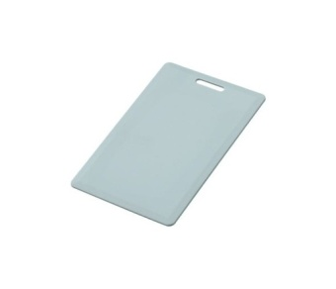

RFID Tag used here is passive Tag. A passive tag is an RFID tag that does not contain a battery; the power is supplied by the reader. When radio waves from the reader are encountered by a passive rfidtag, the coiled antenna within the tag forms a magnetic field. The tag draws power from it, energizing the circuits in the tag.

1. *RFID Reader-*

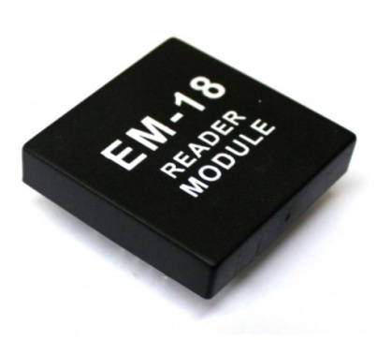

A radio frequency identification reader (RFID reader) is a device used to gather information from an RFID tag, which is used to track individual objects. Radio waves are used to transfer data from the tag to a reader.

1. *Power Supply-*

As we have used a 12V Stepper motor, we have to design a power supply which can provide 12V as well as 5V for microcontroller and other devices.

So, we can use LM7805 IC. This gives two different output voltages.

1. *Display-*

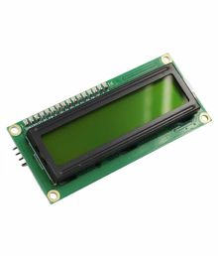

LCD (Liquid Crystal Display) screen is an electronic display module and find a wide range of applications. A 16x2 LCD display is very basic module and is very commonly used in various devices and circuits. These modules are preferred over [seven](http://www.engineersgarage.com/content/seven-segment-display) segment  and other multi segment LED’S The reasons being: LCDs are economical; easily programmable; have no limitation of displaying special & even  custom characters (unlike in seven segments), animations and so on.

A **16x2 LCD** means it can display 16 characters per line and there are 2 such lines. In this LCD each character is displayed in 5x7 pixel matrix. This LCD has two registers, namely, Command and Data.

1. *GSM Module-*

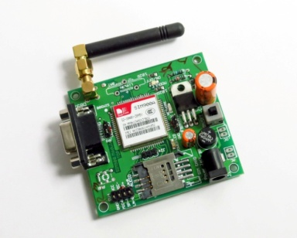

GSM/GPRS module is used to establish communication between a computer and a GSM system. Global System for Mobile communication (GSM) is an architecture used for mobile communication in most of the countries.

1. *IR Sensor-*

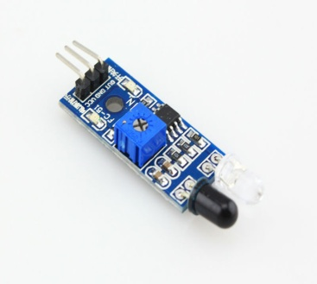

An infrared sensor is an electronic device that emits in order to sense some aspects of the surroundings. An IR sensor can measure the heat of an object as well as detects the motion. These types of sensors measures only infrared radiation, rather than emitting it that is called as a passive IR sensor

1. *Buzzer-*

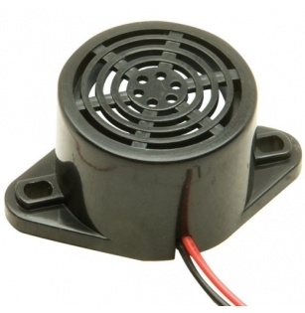

A buzzer or beeper is an [audio](https://en.wikipedia.org/wiki/Sound) signalling device which may be mechanical, electromechanical, or piezoelectric. Typical uses of buzzers and beepers include [alarm devices](https://en.wikipedia.org/wiki/Alarm_devices), [timers](https://en.wikipedia.org/wiki/Timer), and confirmation of user input such as a mouse click or keystroke.

1. *Motor-*

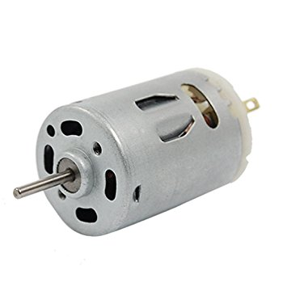

A DC motor is any of a class of electrical machines that converts direct current electrical power into mechanical power. The most common types rely on the forces produced by magnetic fields. Nearly all types of DC motors have some internal mechanism, either electromechanical or electronic, to periodically change the direction of current flow in part of the motor. Most types produce rotary motion; a linear motor directly produces force and motion in a straight line

1. Microcontroller :-

This system uses AT89C52 microcontroller from 8051 family.

1. *Pin Diagram-*

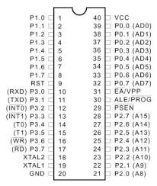

1. *Features of Microcontroller 8051-*

* 8 bit data bus and 8 bit ALU
* 16 bit address bus
* On-Chip RAM-128 Bytes
* On-Chip ROM-4K Byte
* Four 8-bit Bidirectional I/O ports
* Two Multimode 16-bit Timers

1. Software specifications-

Software used in this system are,

1. *Express PCB-*

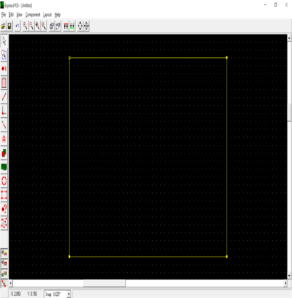

Express PCB is used to design the PCB Layout.

1. *Express SCH-*

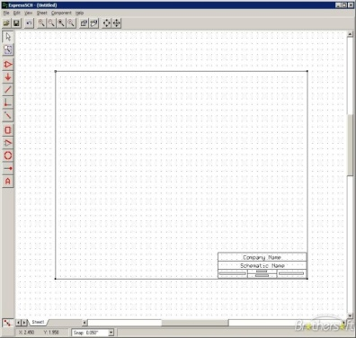

Express SCH is used to design the circuit diagram.

1. *Keil uversion 3-*

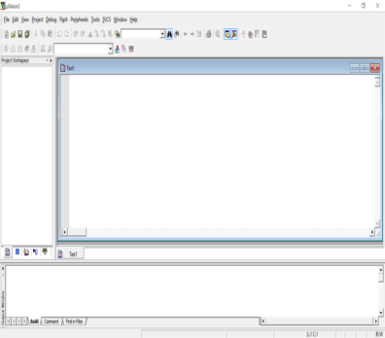

Keil software is for the programming of microcontroller.

1. *MATLAB 7.10.0 -*

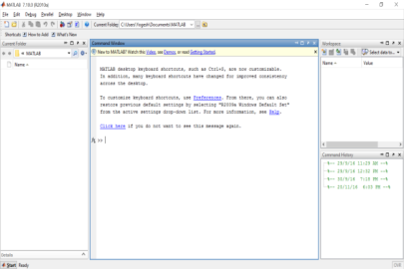

MATLAB software is used for designing the format of the PC screen in which the information is been displayed.

1. Features-

* Man power is reduced.
* We get a message of toll amount and remaining balance in the account.
* Queue in front of toll booths is reduced.
* Pollution gets decreased.
* Toll information is displayed on the screen.
* Fuel consumed is less.
* Traffic gets reduced.
* Requires less time to pay the toll.
* Transparency of Toll Transactions.
* Reduces Revenue Leakages.

1. Scope can be advanced to-
2. As we have used a short range RFID reader, the driver has to take the tag near the reader.
3. But if we use a high range RFID reader, we can stick the tag to the wind shield and the reader will automatically detect the tag from a long range.
4. This way no car has to stop on the toll booth.
5. This system is called as Electronic Toll Collection System.

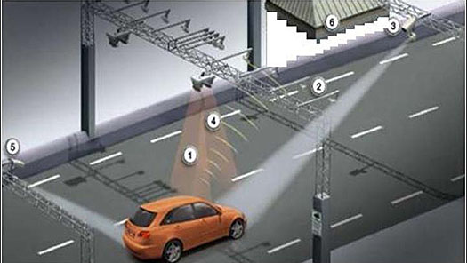

1. Limitations-

If a man owns a truck and a car, he might use the car RFID card for truck. So, he pays fewer tolls for truck.

1. Conclusion-

The proposed RFID Toll collection system discussed in this work applies passive RFID technology. By doing so, increased efficiency will be guaranteed since RFID is known as a highly stable technology. With the elimination of human interaction in the entire toll collection process, we can create a better toll collection system to be implemented in India. It can also significantly improve the efficiency of toll stations and the traffic abilities of the toll road.

1. References-

[1] ELECTRONIC TOLL COLLECTION SYSTEM- <https://en.wikipedia.org/wiki/Electronic_toll_collection>

### [2] Automated Toll Collection System Using RFID

<http://www.iosrjournals.org/iosr-jce/papers/Vol9-Issue2/L0926166.pdf?id=283>

**[3]** How does RFID Toll Collection System works?

<http://www.rfidjournal.com/blogs/experts/entry?10743>

[4] Dr. Paul Polishuk, Hui Pan, “RFID Monthly Newsletter”, Page 12, volume 3, number 9, September 2006.

[5] Sudha Bhalekar, Adesh Chanegiri G., Indra Prakash Chauhan “automatic Toll Tax using RFID”, IJCTEE Volume 3, Special Issue, March-April 2013.

[6] C.M. Roberts, “Radio Frequency Identification (RFID),” Computers & Security, Elsevier, 2006.